Q.1 ANS - A) Create, D) ALTER

Q.2 ANS- A) Update, B) Delete

Q.3 ANS- B) Structured Query Language

Q.4 ANS- B) Data Definition Language

Q.5 ANS- A) Data Manipulation Language

Q.6 ANS- Create Table A (B int,C float)

Q.7 ANS- B) Alter Table A ADD COLUMN D float

Q.8 ANS- B) Alter Table A Drop Column D

Q.9 ANS- B) Alter Table A Alter Column D int

Q.10 ANS - C) Alter Table A Add Primary key B

**Q.11. What is data-warehouse?**

ANS - A **Data Warehousing** (DW) is process for collecting and managing data from varied sources to provide meaningful business insights. A Data warehouse is typically used to connect and analyze business data from heterogeneous sources. The data warehouse is the core of the BI system which is built for data analysis and reporting.

It is a blend of technologies and components which aids the strategic use of data. It is electronic storage of a large amount of information by a business which is designed for query and analysis instead of transaction processing. It is a process of transforming data into information and making it available to users in a timely manner to make a difference.

The decision support database (Data Warehouse) is maintained separately from the organization's operational database. However, the data warehouse is not a product but an environment. It is an architectural construct of an information system which provides users with current and historical decision support information which is difficult to access or present in the traditional operational data store.

A Data Warehouse works as a central repository where information arrives from one or more data sources. Data flows into a data warehouse from the transactional system and other relational databases.

Data may be:

1. Structured
2. Semi-structured
3. Unstructured data

The data is processed, transformed, and ingested so that users can access the processed data in the Data Warehouse through Business Intelligence tools, SQL clients, and spreadsheets. A data warehouse merges information coming from different sources into one comprehensive database.

By merging all of this information in one place, an organization can analyze its customers more holistically. This helps to ensure that it has considered all the information available. Data warehousing makes data mining possible. Data mining is looking for patterns in the data that may lead to higher sales and profits.

**12. What is the difference between OLTP VS OLAP?**

ANS – 1) **OLAP** -Online Analytical Processing, a category of software tools which provide analysis of data for business decisions. OLAP systems allow users to analyze database information from multiple database systems at one time. This is widely used by Data scientists and Analysts in Data mining and Business analytics as it uses data warehouse. A data warehouse is created uniquely so that it can integrate different data sources for building a consolidated database for business decision decision making thus it is characterized by a large volume of data

**Example** – Amazon analyzes purchases by its customers to come up with a personalized homepage with products which likely interest to their customer (BI, Consumer behaviour analysis, User recommending etc.) .

2) **OLTP** -Online transaction processing shortly known as OLTP supports transaction-oriented applications in a 3-tier architecture. OLTP administers day to day transaction of an organization. It is used by Data critical users like clerk, DBA & Data Base professionals and designed for real time business operations so, OLTP uses traditional DBMS. OLTP is designed to have fast response time, low data redundancy and is normalized.

**Example –** Online Banking

**13. What are the various characteristics of data-warehouse?**

ANS – The characteristics of data-warehouse are as follows-

* Subject Oriented
* Integrated
* Non-volatile
* Time Variant
* **Subject Oriented**
  + A data warehouse is subject oriented because it provides information around a subject rather than the organization's ongoing operations.
  + These subjects can be product, customers, suppliers, sales, revenue, etc. A data warehouse does not focus on the ongoing operations, rather it focuses on modelling and analysis of data for decision making.
* **Integrated**
  + A data warehouse is constructed by integrating data from heterogeneous sources such as relational databases, flat files, etc.
  + This integration enhances the effective analysis of data.
* **Time Variant**
  + The data collected in a data warehouse is identified with a particular time period.
  + The data in a data warehouse provides information from the historical point of view.
* **Non-volatile**
  + Non-volatile means the previous data is not erased when new data is added to it.

A data warehouse is kept separate from the operational database and therefore frequent changes in operational database is not reflected in the data warehouse.

The key characteristics of a data warehouse are as follows:

* Some data is denormalized for simplification and to improve performance.
* Queries often retrieve large amounts of data.
* Both planned and ad hoc queries are common.
* The data load is controlled.

In general, high data throughput is the key to a successful data warehouse

**14. What is Star-Schema??**

ANS - **Star Schema** in data warehouse, in which the center of the star can have one fact table and a number of associated dimension tables. It is known as star schema as its structure resembles a star. The Star Schema data model is the simplest type of Data Warehouse schema. It is also known as Star Join Schema and is optimized for querying large data sets.

In the following Star Schema example, the fact table is at the center which contains keys to every dimension table like Dealer_ID, Model ID, Date_ID, Product_ID, Branch_ID & other attributes like Units sold and revenue.

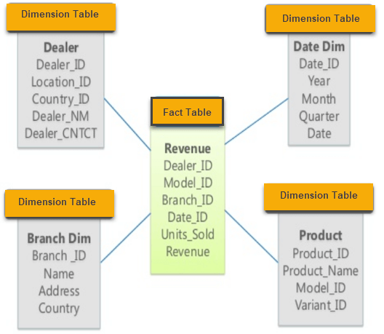

**Characteristics of Star Schema**:

* Every dimension in a star schema is represented with the only one-dimension table.
* The dimension table should contain the set of attributes.
* The dimension table is joined to the fact table using a foreign key
* The dimension table are not joined to each other
* Fact table would contain key and measure
* The Star schema is easy to understand and provides optimal disk usage.
* The dimension tables are not normalized. For instance, in the above figure, Country_ID does not have Country lookup table as an OLTP design would have.
* The schema is widely supported by BI Tools

**15. What do you mean by SETL?**

ANS - Short for *Set Theory as a Language* (or Set Language), SETL is a [high-level programming language](https://www.webopedia.com/definitions/high-level-language/) that’s based on the mathematical theory of sets. It was developed in the early 1970’s by mathematician Professor J. Schwartz. SETL is an interpreted language with a [syntax](https://www.webopedia.com/definitions/syntax/) that is resembles [C](https://www.webopedia.com/definitions/c-language/) and in many cases similar to [Perl](https://www.webopedia.com/definitions/perl/). In SETL every statement is terminated by a semicolon. [Variable](https://www.webopedia.com/definitions/variable/) names are case-insensitive and are automatically determined by their last assignment.